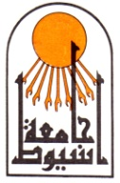

Assiut University
Faculty of Medicine
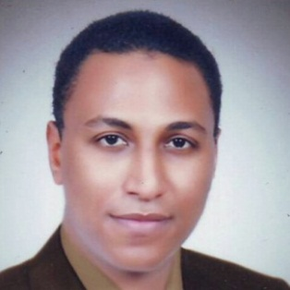

CURRICULUM VITAE

Personal data:

Name: Ramy Mohammed Ahmed

Address: Assiut University Hospital , Assiut, Egypt

Telephone:
Office: (+2088)2413140
Mobile: (+2)01119057535
  - Fax: (+2088)(2343308)
  - E-Mail: ramycolor@aun.edu.eg

Birth date: December 21st, 1985

Sex: Male.

Nationality: Egyptian.

Marital Status: Married

Professional Title and Address:

Assistant lecturer of Radiodiagnosis , Faculty of Medicine, Assiut University, Assiut, Egypt.

Educational Background:

September, 2008: M.B.B.Ch in Surgery and Medicine, Faculty of Medicine, Assiut University, Egypt. (With general grade of Excellent with Honor).

December , 2013: M.Sc. in Radiodiagnosis , Faculty of Medicine, Assiut University, Egypt. (With general grade very good).

Training Experience:

3/2009To 2/2010: Intern, Assiut University Hospital, Assiut, Egypt.

3/2010 up to 2/2013: Resident of Radiodiagnosis , Assiut University Hospital, Assiut, Egypt.

3/2013 up to date : Assisstant Lecturer of Diagnostic radiology , Assiut University Hospital, Assiut, Egypt. and Al-Rajhy liver center, Assiut University Hospital, Assiut, Egypt.

Duties (July, 2009 – up to date):

Supervising and directing residents and fellows at our department

Regularly participating in the departmental educational meetings, audit meetings, and regional scientific meetings. I also actively share in preparing and presenting lectures for the weekly scientific meetings and annual basic and clinical science courses in the department.

Helping in the research programs held at our department.

24 hours shifts, twice a week, dealing with traumatic or medical cases need urgent interventional radiological procedure .

6 hours in our department imaging untis responsible for reporting a diagnosis for cases. Four days weekly .

M.D. Thesis:

Role of MDCT in bronchopulmonary malformations . (Essay)

Additional Experience:

Performing the following operations in Assiut University Hospital (March 2008 till now):

At the interventional sonar unit:

Percutaneous Ethanol injection of HCC.

Liver abscess drainage by pig tail catheter insertion .

Liver biopsy.

Pancreatic psuedocyst drainage by pig tail catheterization

Also Performing :

Trans Arterial Chemo Embolization for Hepatocellular Carcinoma Patients.

Percutaneous transhepatic chlangiogram and Drainage for Malignant biliary obstruction .

General Interests and Skills

Computer work and Information Technology, Reading, walking.

Sporting: football.

Mother language: Arabic.

Foreign Languages: English, All medical studies and exams in English .

References:

Prof. Dr. Mostafa Hashim, Professor of Radiodiology Department, Assiut University Hospital, Assiut, Egypt. Tel. (+20100064012). E-mail: hashemradiol@yahoo.com

Prof. Dr. Hany Seif , Professor of Radiology Department, Assiut University Hospital, Assiut, Egypt. Tel (+201119159500)
References and certificates are available on demand.

